CAS Server部署

安装文件：
需要的安装文件
- apache-tomcat-7.0.54.tar.gz （tamcat7 linux64位版本即可)
- jdk-7u55-linux-x64.tar.gz (JDK7 linux64位版本即可)
- 对应系统部署包及证书文件

拷贝文件
- 打开XSHELL，连接需要部署的服务器
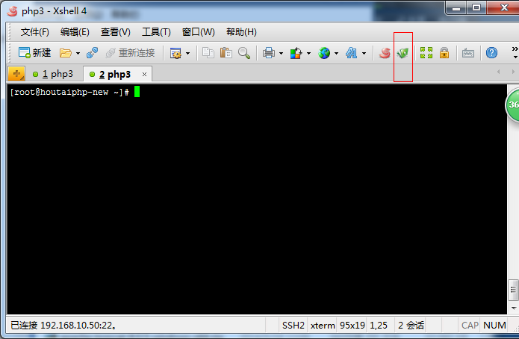
点击菜单栏绿色小图标（新建文件传输）
在打开的对话框中，左侧找到本机所在的tomcat和jdk压缩包，拖动到右侧，完成传输

配置环境变量：
进入传输后的文件夹，执行
命令 :
tar –zxvf jdk-7u51-linux-x64.tar.gz
tar –zxvf apache-tomcat-7.0.53.tar.gz
使用vim 进入根目录下的配置文件
vi ~/.bashrc

输入 i，在文件末尾加上

export JAVA_HOME=/root/jdk1.7.0_55
export JRE_HOME=$JAVA_HOME/jre
export CLASSPATH=.:JAVA_HOME/lib:$JRE_HOME/lib
export PATH=$JAVA_HOME/bin:$PATH
Esc+:wq 保存退出。

导入证书
keytool -import -keystore $JRE_HOME/lib/security/cacerts -file /root/imooly.com/key+crt/ca1_ov.crt -alias CaOvCert
输入密码,默认密码为changeit
接着输入yes
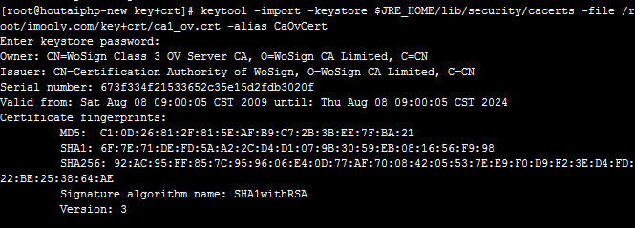
出现Certificate was added to keystore 则说明安装正常
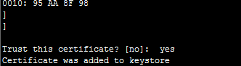
同样导入
可以用 keytool -list -keystore $JRE_HOME/lib/security/cacerts 检查是否导入

tomcat 配置:
进入tomcat路径下，找到conf 文件夹下的server.xml
配置如下
<?xml version='1.0' encoding='utf-8'?>
<!--
Licensed to the Apache Software Foundation (ASF) under one or more
contributor license agreements. See the NOTICE file distributed with
this work for additional information regarding copyright ownership.
The ASF licenses this file to You under the Apache License, Version 2.0
(the "License"); you may not use this file except in compliance with
the License. You may obtain a copy of the License at

http://www.apache.org/licenses/LICENSE-2.0

Unless required by applicable law or agreed to in writing, software
distributed under the License is distributed on an "AS IS" BASIS,
WITHOUT WARRANTIES OR CONDITIONS OF ANY KIND, either express or implied.
See the License for the specific language governing permissions and
limitations under the License.
-->
<!-- Note: A "Server" is not itself a "Container", so you may not
define subcomponents such as "Valves" at this level.
Documentation at /docs/config/server.html
-->
<Server port="8015" shutdown="SHUTDOWN">
<!-- Security listener. Documentation at /docs/config/listeners.html
<Listener className="org.apache.catalina.security.SecurityListener" />
-->
<!--APR library loader. Documentation at /docs/apr.html -->
<Listener className="org.apache.catalina.core.AprLifecycleListener" SSLEngine="on" />
<!--Initialize Jasper prior to webapps are loaded. Documentation at /docs/jasper-howto.html -->
<Listener className="org.apache.catalina.core.JasperListener" />
<!-- Prevent memory leaks due to use of particular java/javax APIs-->
<Listener className="org.apache.catalina.core.JreMemoryLeakPreventionListener" />
<Listener className="org.apache.catalina.mbeans.GlobalResourcesLifecycleListener" />
<Listener className="org.apache.catalina.core.ThreadLocalLeakPreventionListener" />

<!-- Global JNDI resources
Documentation at /docs/jndi-resources-howto.html
-->
<GlobalNamingResources>
<!-- Editable user database that can also be used by
UserDatabaseRealm to authenticate users
-->
<Resource name="UserDatabase" auth="Container"
type="org.apache.catalina.UserDatabase"
description="User database that can be updated and saved"
factory="org.apache.catalina.users.MemoryUserDatabaseFactory"
pathname="conf/tomcat-users.xml" />

</GlobalNamingResources>

<!-- A "Service" is a collection of one or more "Connectors" that share
a single "Container" Note: A "Service" is not itself a "Container",
so you may not define subcomponents such as "Valves" at this level.
Documentation at /docs/config/service.html
-->
<Service name="Catalina">

<!--The connectors can use a shared executor, you can define one or more named thread pools-->
<!--
<Executor name="tomcatThreadPool" namePrefix="catalina-exec-"
maxThreads="150" minSpareThreads="4"/>
-->

<!-- A "Connector" represents an endpoint by which requests are received
and responses are returned. Documentation at :
Java HTTP Connector: /docs/config/http.html (blocking & non-blocking)
Java AJP Connector: /docs/config/ajp.html
APR (HTTP/AJP) Connector: /docs/apr.html
Define a non-SSL HTTP/1.1 Connector on port 8080
-->
<Connector port="8080" protocol="HTTP/1.1"
connectionTimeout="20000"
redirectPort="8443" />
<!-- A "Connector" using the shared thread pool-->
<!--
<Connector executor="tomcatThreadPool"
port="8080" protocol="HTTP/1.1"
connectionTimeout="20000"
redirectPort="8444" />
-->
<!-- Define a SSL HTTP/1.1 Connector on port 8443
This connector uses the BIO implementation that requires the JSSE
style configuration. When using the APR/native implementation, the
OpenSSL style configuration is required as described in the APR/native
documentation -->
<Connector port="8443" protocol="org.apache.coyote.http11.Http11Protocol"
maxThreads="150" SSLEnabled="true" scheme="https" secure="true"
clientAuth="false" sslProtocol="TLS" keystoreFile="/root/imooly.com/jks/SSL.jks" keystorePass="**********"/>

<!-- Define an AJP 1.3 Connector on port 8009 -->
<Connector port="8019" protocol="AJP/1.3" redirectPort="8444" />

<!-- An Engine represents the entry point (within Catalina) that processes
every request. The Engine implementation for Tomcat stand alone
analyzes the HTTP headers included with the request, and passes them
on to the appropriate Host (virtual host).
Documentation at /docs/config/engine.html -->

<!-- You should set jvmRoute to support load-balancing via AJP ie :
<Engine name="Catalina" defaultHost="localhost" jvmRoute="jvm1">
-->
<Engine name="Catalina" defaultHost="localhost">

<!--For clustering, please take a look at documentation at:
/docs/cluster-howto.html (simple how to)
/docs/config/cluster.html (reference documentation) -->
<!--
<Cluster className="org.apache.catalina.ha.tcp.SimpleTcpCluster"/>
-->

<!-- Use the LockOutRealm to prevent attempts to guess user passwords
via a brute-force attack -->
<Realm className="org.apache.catalina.realm.LockOutRealm">
<!-- This Realm uses the UserDatabase configured in the global JNDI
resources under the key "UserDatabase". Any edits
that are performed against this UserDatabase are immediately
available for use by the Realm. -->
<Realm className="org.apache.catalina.realm.UserDatabaseRealm"
resourceName="UserDatabase"/>
</Realm>

<Host name="localhost" appBase="webapps"
unpackWARs="true" autoDeploy="true">
<Context path=" " docBase="/root/apache-tomcat-7.0.54/webapps/business" debug="0" reloadable="true" crossContext="true" />
<!-- SingleSignOn valve, share authentication between web applications
Documentation at: /docs/config/valve.html -->
<!--
<Valve className="org.apache.catalina.authenticator.SingleSignOn" />
-->

<!-- Access log processes all example.
Documentation at: /docs/config/valve.html
Note: The pattern used is equivalent to using pattern="common" -->
<Valve className="org.apache.catalina.valves.AccessLogValve" directory="logs"
prefix="localhost_access_log." suffix=".txt"
pattern="%h %l %u %t &quot;%r&quot; %s %b" />

</Host>
</Engine>
</Service>
</Server>

Tomat启动与关闭：
进入tomat的bin目录下，
启动 ./shutdown.sh
关闭 ./startup.sh
启动后可到logs目录下的catalina.out文件中，查看启动日志。

